IFT 598: Middleware Prog & Database Sec (2022 Fall)

Module 4 Assignment: Setting up MongoDB in Cloud

Name: Sai Mrunaal Chatlapally

Class: 2022Fall-P-IFT458-IFT598-82341-82345

Date: 10-08-2022

* **Step 1: Creating account in Atlas** 
  + Cluster creation

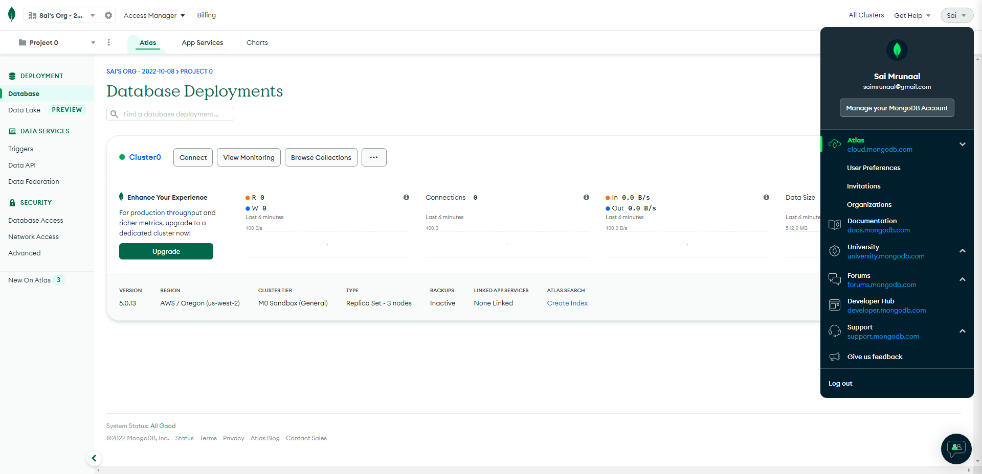

* + New project

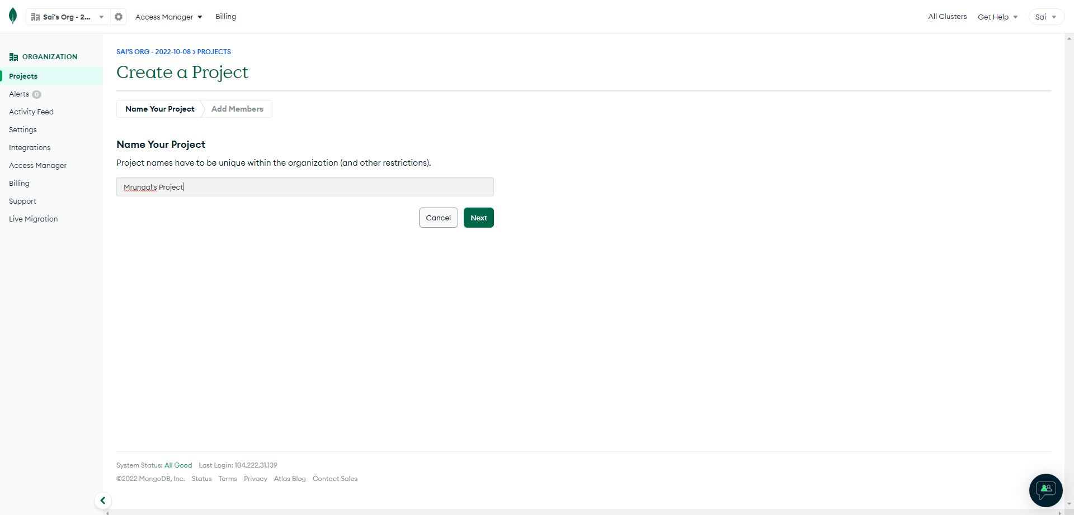

* + Inserting Documents:

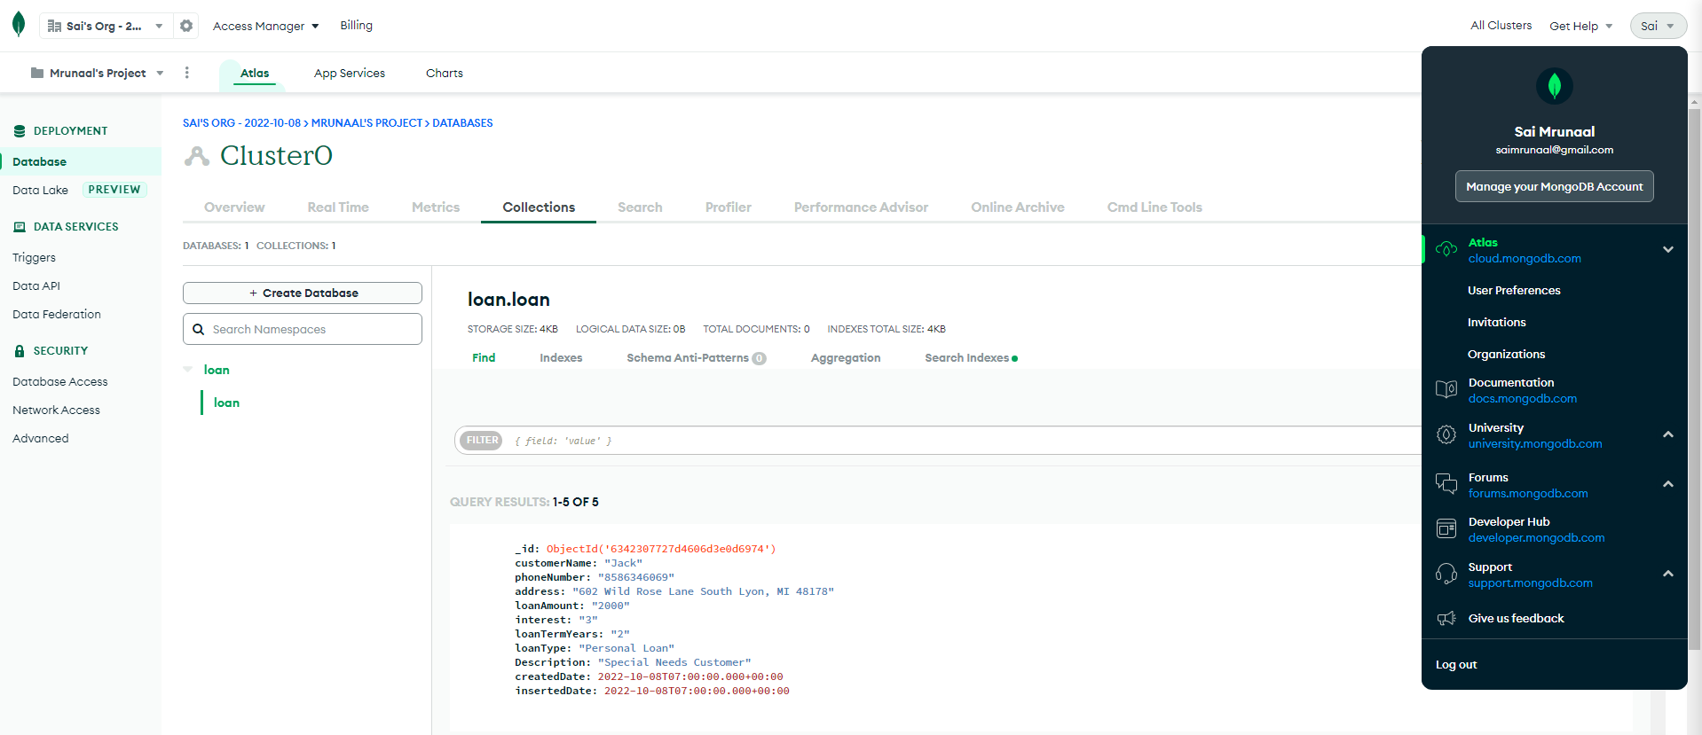

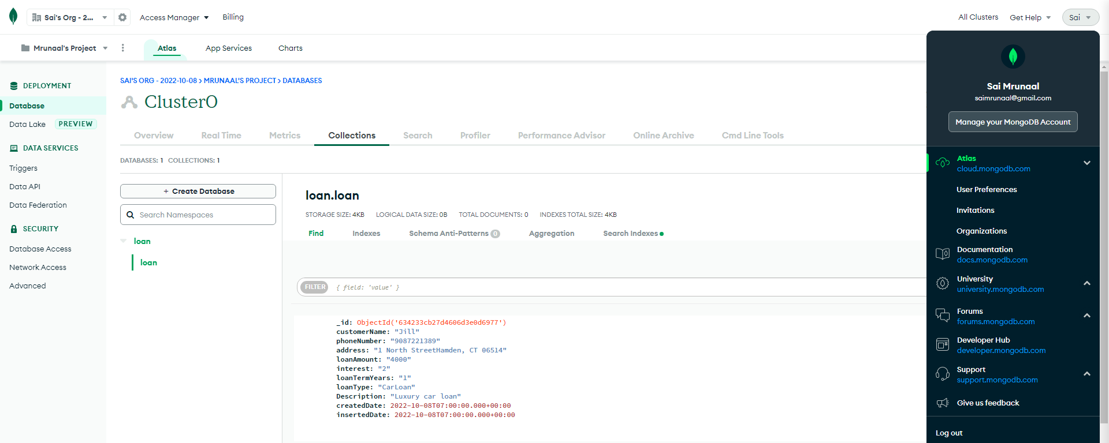

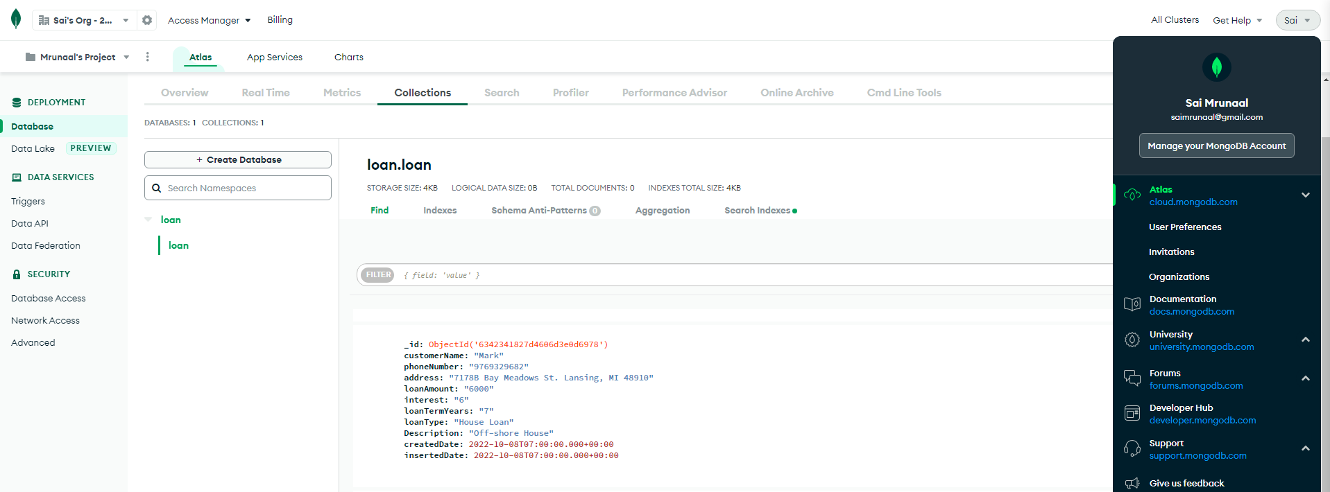

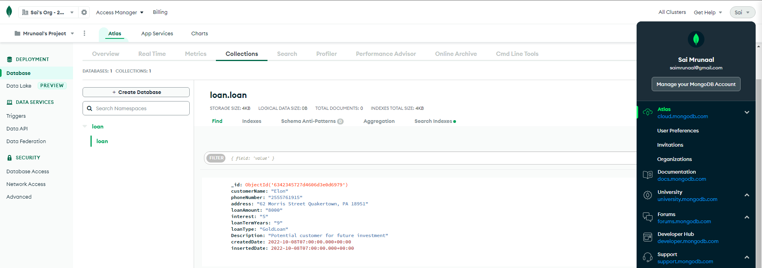

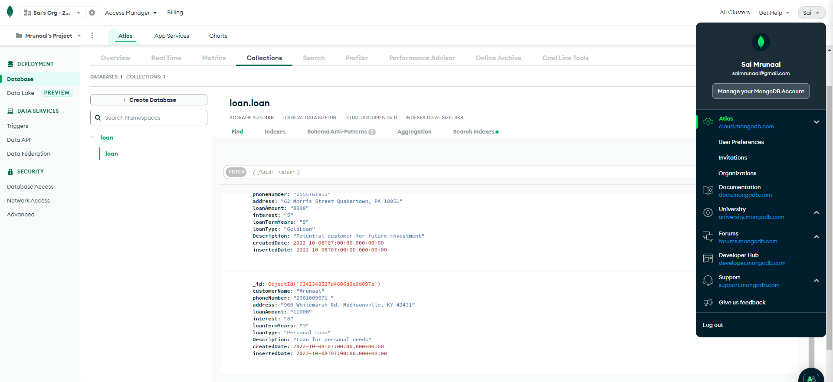

* **Step 2**
  + Npm install

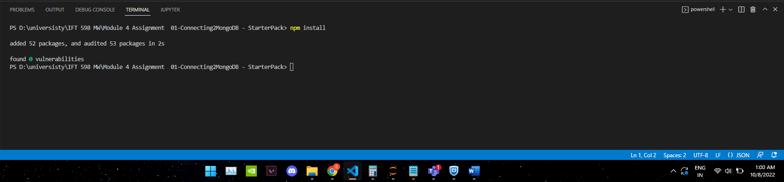

* **Step 3**
  + Creating new folder schemas and file loanSchema.js

Basic Schema Definition:

//Student name: Sai Mrunaal Chatlapally

//Student ID: 1222235300

//Date Created: 10/08/2022

//Short Description: In this project we had learnt

// -mongoose and how to create schemas.

// -MongoDB Atlas and how to add and query data

import mongoose from 'mongoose';

const { Schema } = mongoose;

const loanSchema = new Schema({

Id: String,

customerName: String,

phoneNumber: String,

address: String,

loanAmount: String,

interest: String,

loanTermYears : String,

loanType: String,

description: String

});

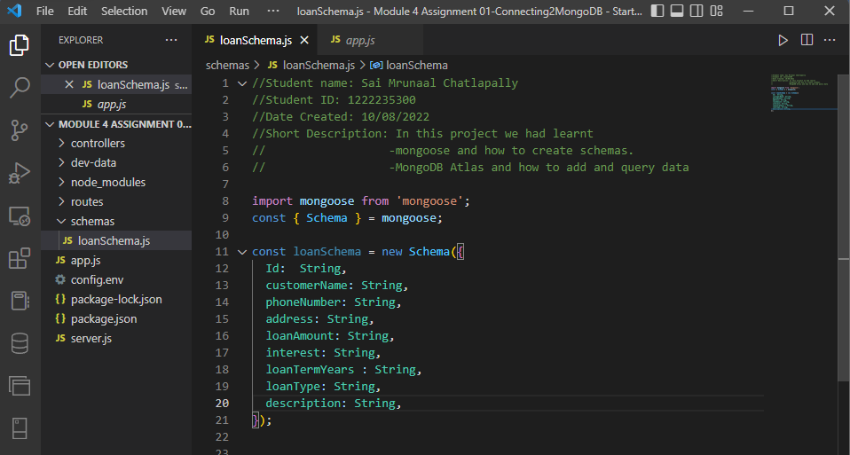

* **Step 4:**

**Write the importance of schema definition and the need for schema definition for a sanitized documents in respect to MongoDB NoSQL database.  Also mentions the datatypes that are available in MongoDB.**

Schema definition consists of properties and their corresponding SchemaTypes. For example let us take one of our attributes customerName from our above defined schema, it is cast to String SchemaType.

Keys can also be assigned to nested objects which contain proper key or type definitions and it happens when the key’s value is a POJO and it doesn’t have a corresponding type.

Ex: customerName:{

firstName: String,

lastName: String

}

Mongoose creates schema paths for the leaves in the tree but not for POJO and they don’t have actual paths. In the above example we can see firstName and lastName won’t have their actual paths and if they need one the path needs to be created up the tree.

Permitted datatypes in MongoDB: String, Number, Date, Buffer, Boolean, Mixed, ObjectId, Array, Decimal128, Map.

* **Step 5: MongoDB/Mongoose Database Models:**
  + Refining Schema and adding createdDate and insertedDate:

Code:

import mongoose from 'mongoose';

const { Schema } = mongoose;

const loanSchema = new Schema({

Id: String,

customerName: String,

phoneNumber: String,

address: String,

loanAmount: String,

interest: String,

loanTermYears : String,

loanType: String,

description: String,

createdDate: Date,

insertedDate: Date

});

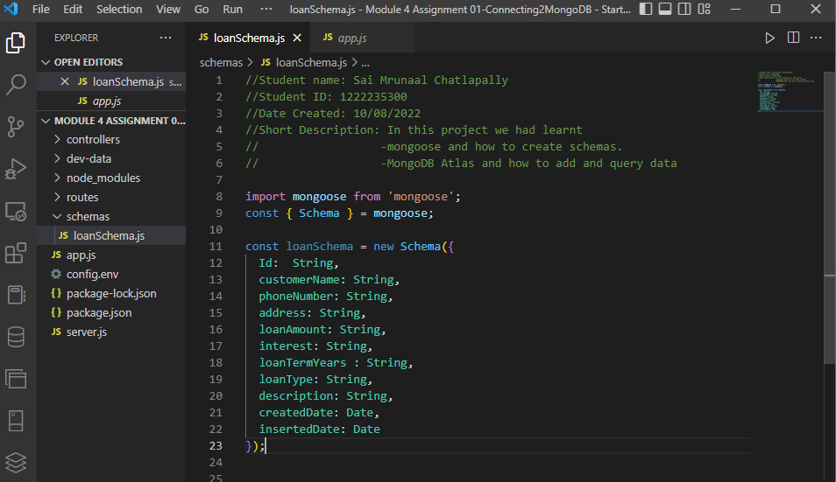

* + Use the ATLAS MongoDB UI to query
    - CustomerName:

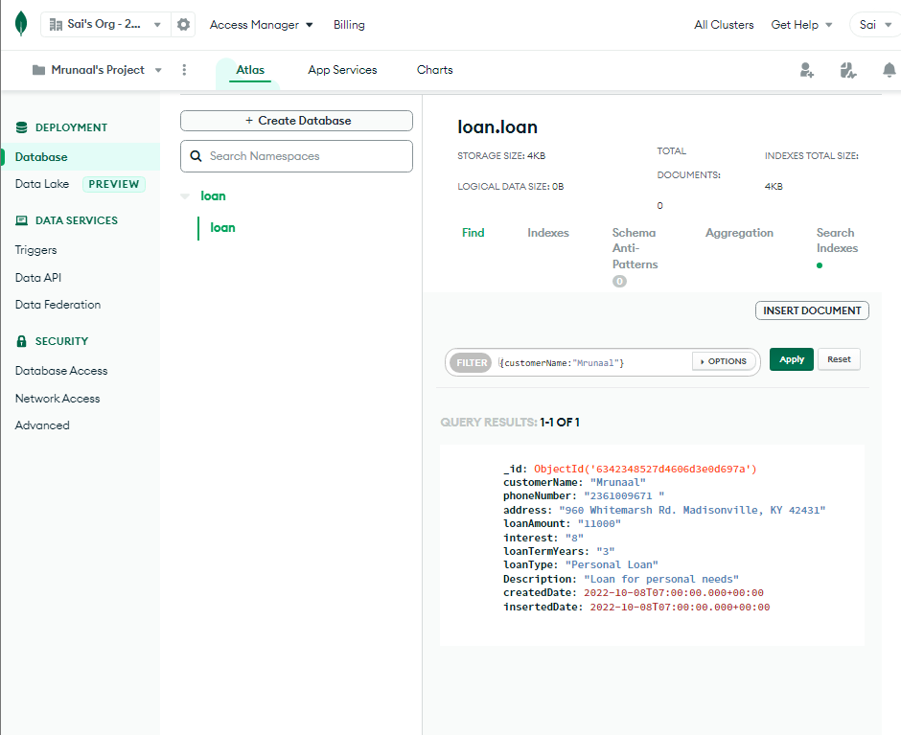

* + - _id:

